**AutoScaling**

**Benefits:**

1. Shrink or expand the instances based on load
2. Cost effective as we spin up instance only on demand

CloudWatch used to do monitor of latency or cpu threshold met.

By default above two mechanism is included in cloudwatch except cloud watch alarm

**AutoScaling Components**

1. Launch Configuration
2. Auto scale group
   1. Set ec2 maximum instance above what we expect
3. Cloud Watch Alarm
   1. When this alarm is triggered it will invoke scaling policy which will say what to do

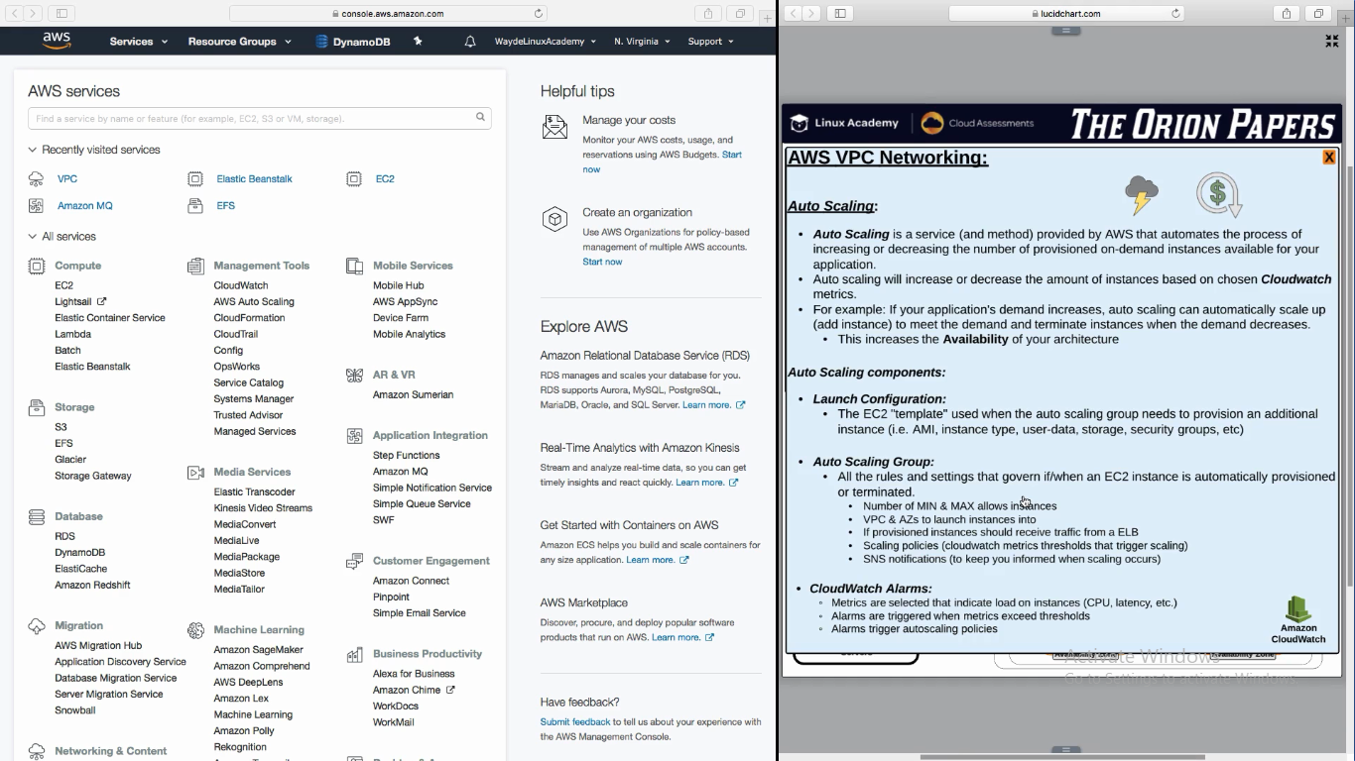

**CloudWatch**

1. Create custom metrics by writing a script
   1. Eg: Number of users logged in

**Auto Scaling Steps:**

1. Create Load Balancer
2. Create Load Balancer Security group
3. Create Target group for load balancer to send the traffic
   1. In advanced section, give threshold level to check if instance is healthy or not, in what frequency it have to check etc
4. Target (here is where we say which instance to be spinned). We will do it in launch configuration in AutoScalling

1.

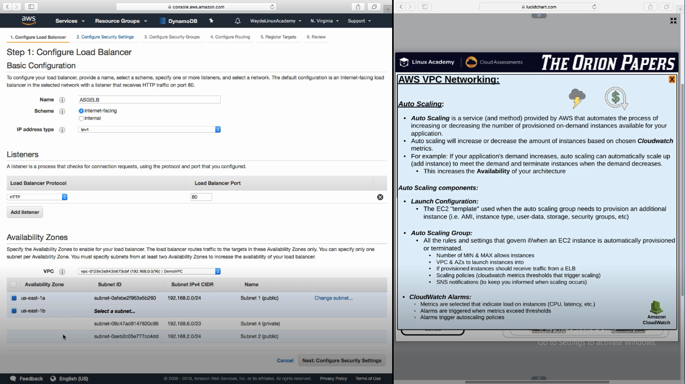

2.

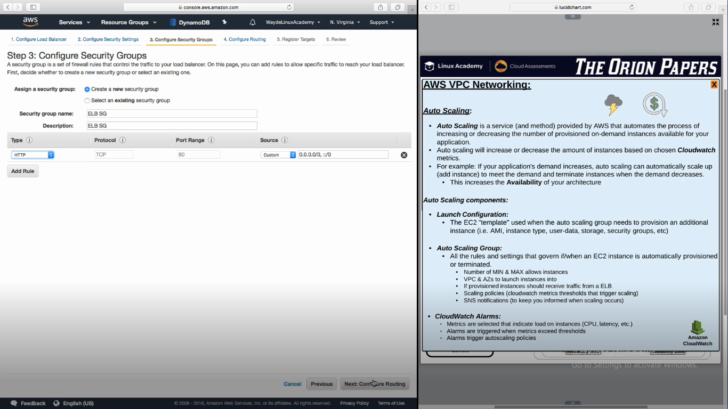

3.

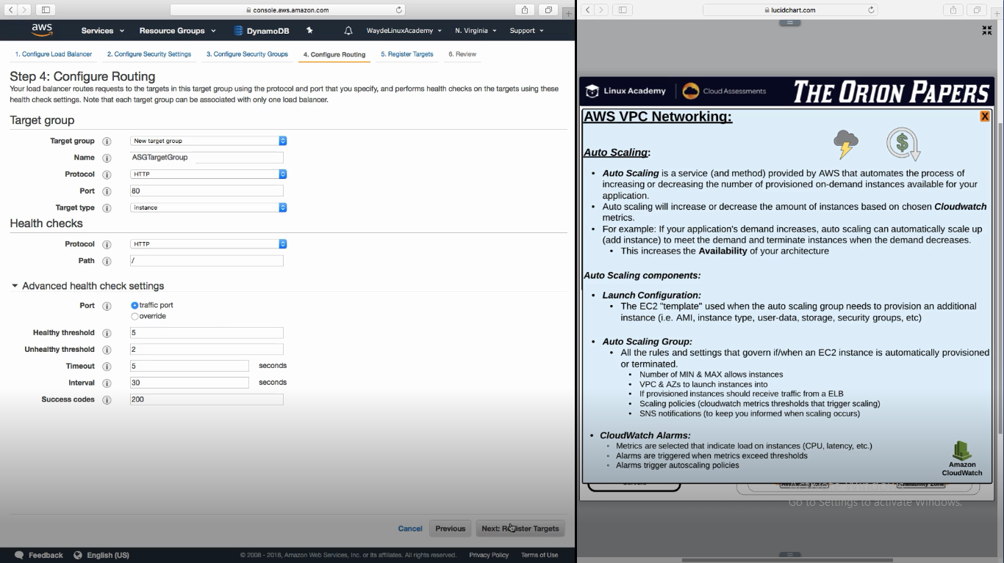

**Create AutoScaling Group**

1. Launch Configuration
2. In security group configure http so that it will accept connection only from load balancer
3. Select how many instance we need, attach it to vpc and select subnet

1.

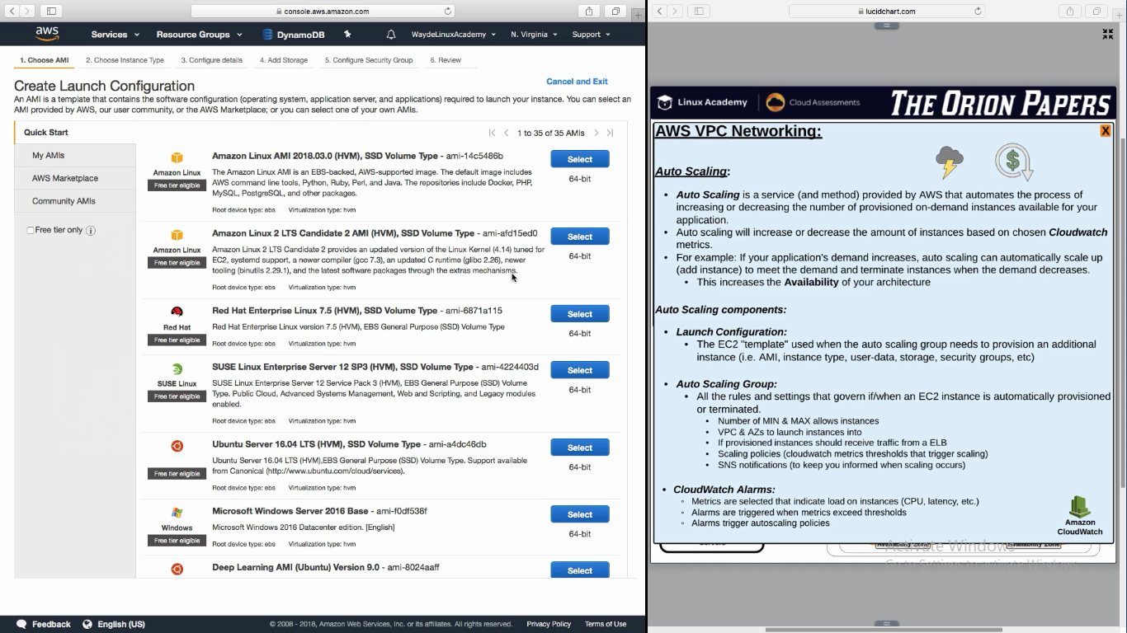

2.

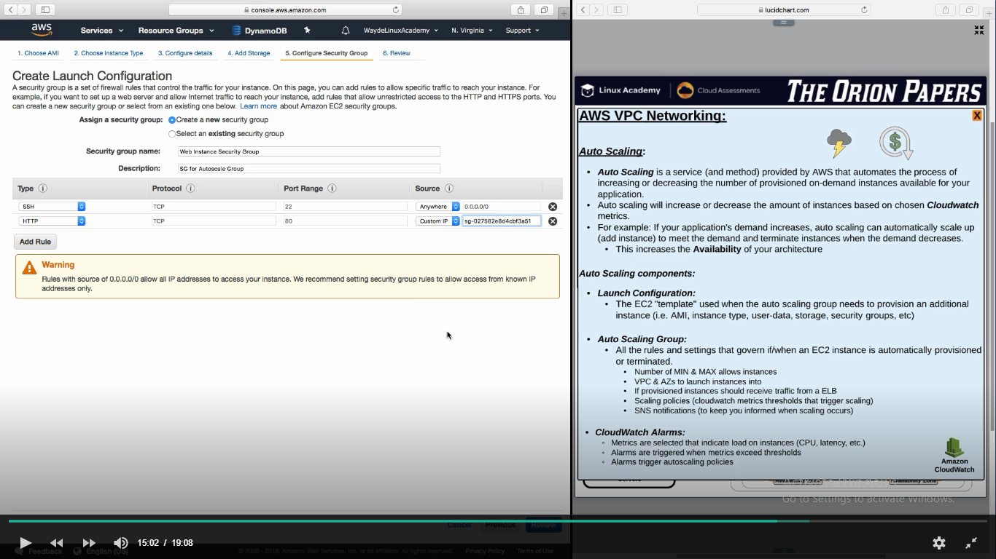

3.

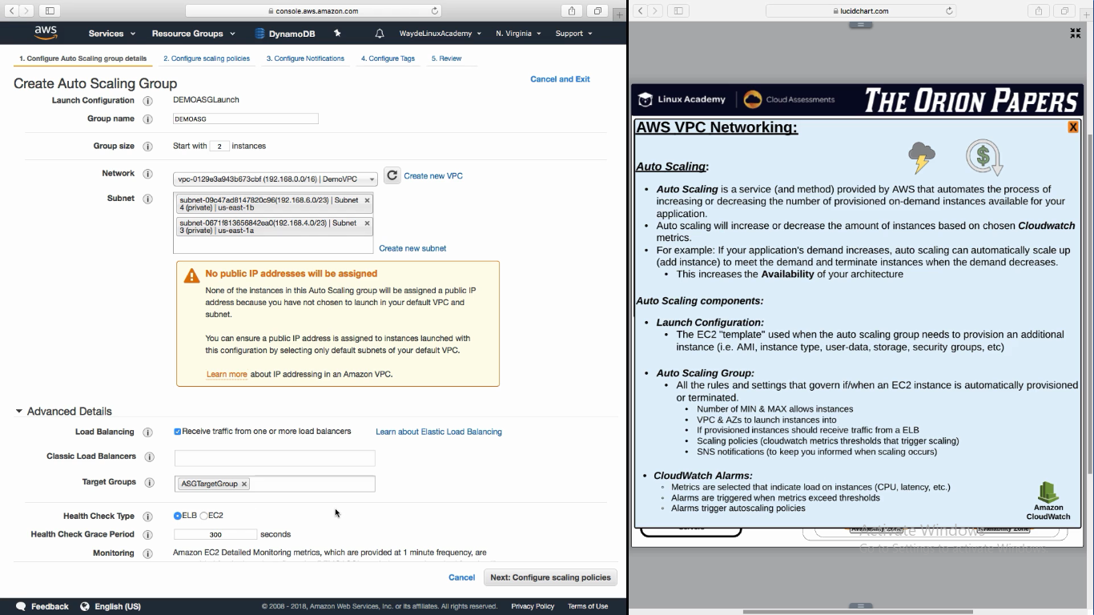

**Handson – Creating AutoScaling**

Create Load Balancer

Create Auto Scaling Group

Launch Configuration

Auto Scaling group

1. **Create Load Balancer**

AWS Console -> EC2 -> Load Balancing -> Load Balancers -> Create Load Balancer -> Application Load Balancer

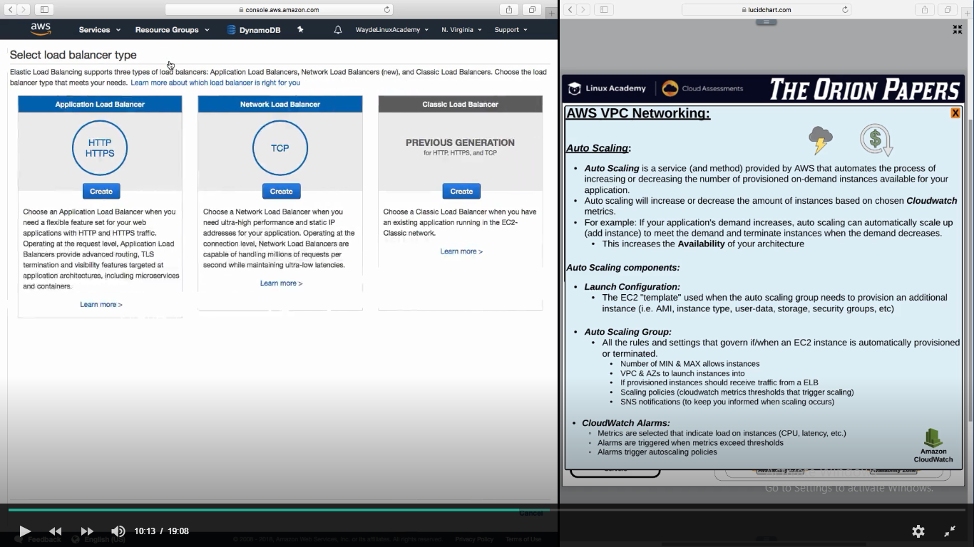

Select **Internet facing** if it is a web application

Select HTTP protocol for load balancing

Choose the VPC for load balancing

Choose the subnets where the load need to sent -> We can select only the public subnet as the Load Balancing is internet facing

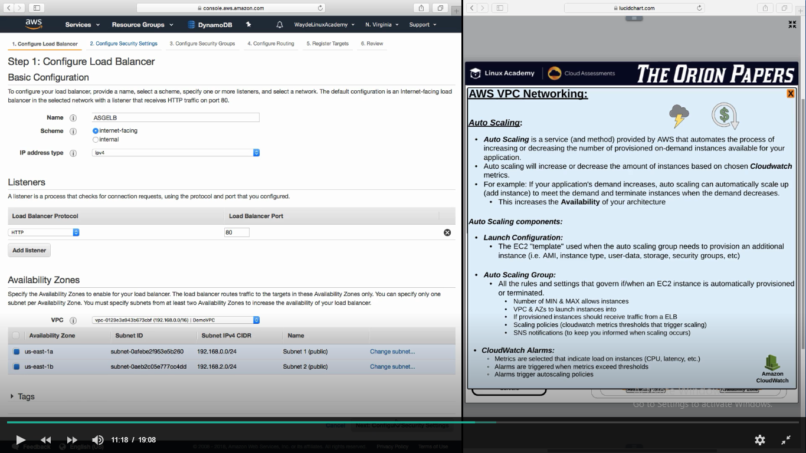

1. Configure security group
   1. Allow HTTP

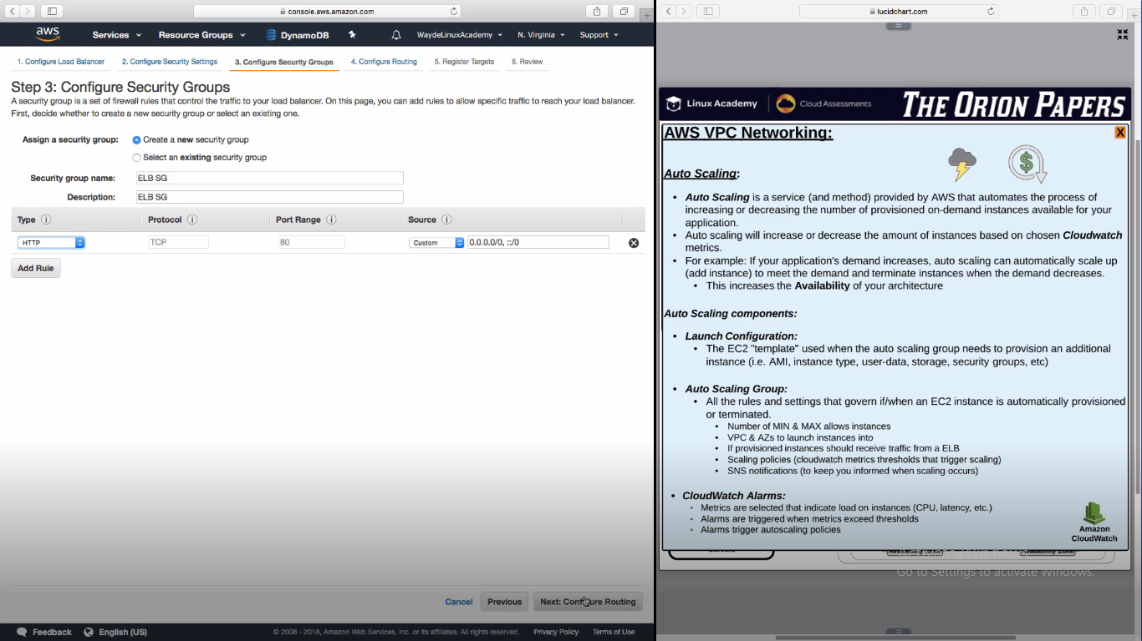

1. **Create Target Group for load balancer to send traffic**

We can select ip address also (if we want to route traffic to a server) than selecting an instance

Mention health check configurations

Click Register Target after giving below info

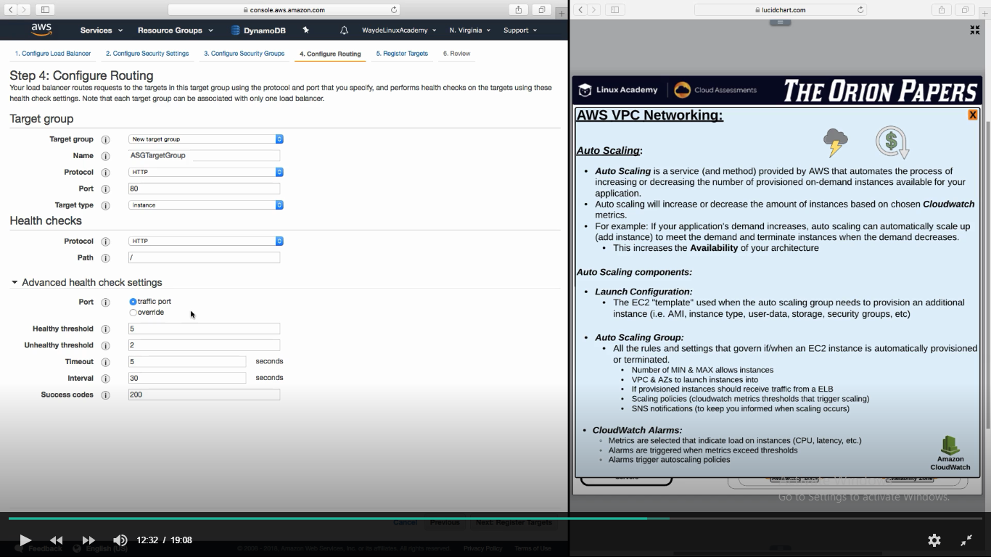

**Register Target:**

Register Target is the place where we add instances to which load balancer is going to send traffic

We can skip this as autoscalling will do this for us

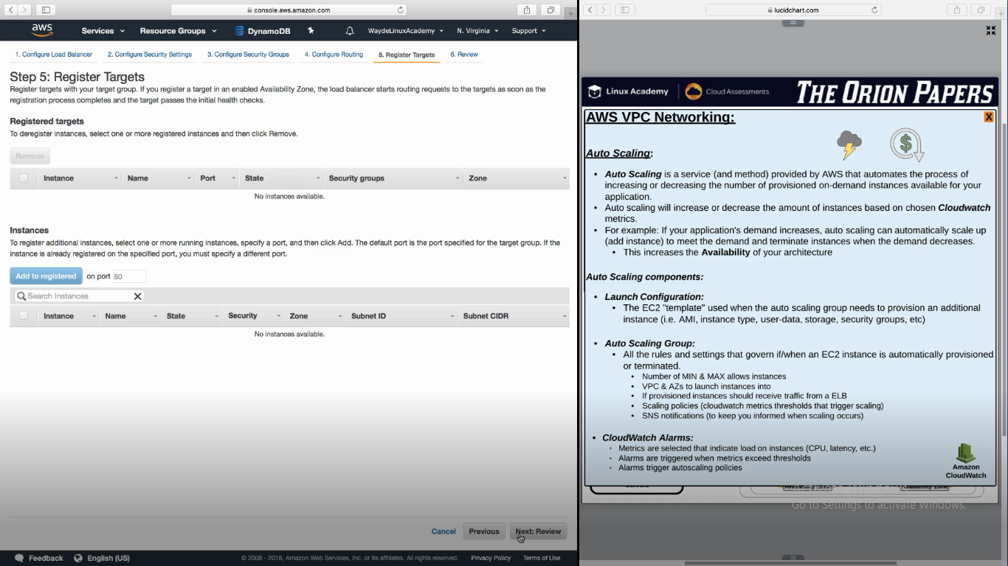

Review and create.

**Setup Auto Scaling Group**

1. AWS Console -> Load Balancing -> Auto Scaling Groups -> Create Auto Scaling Group

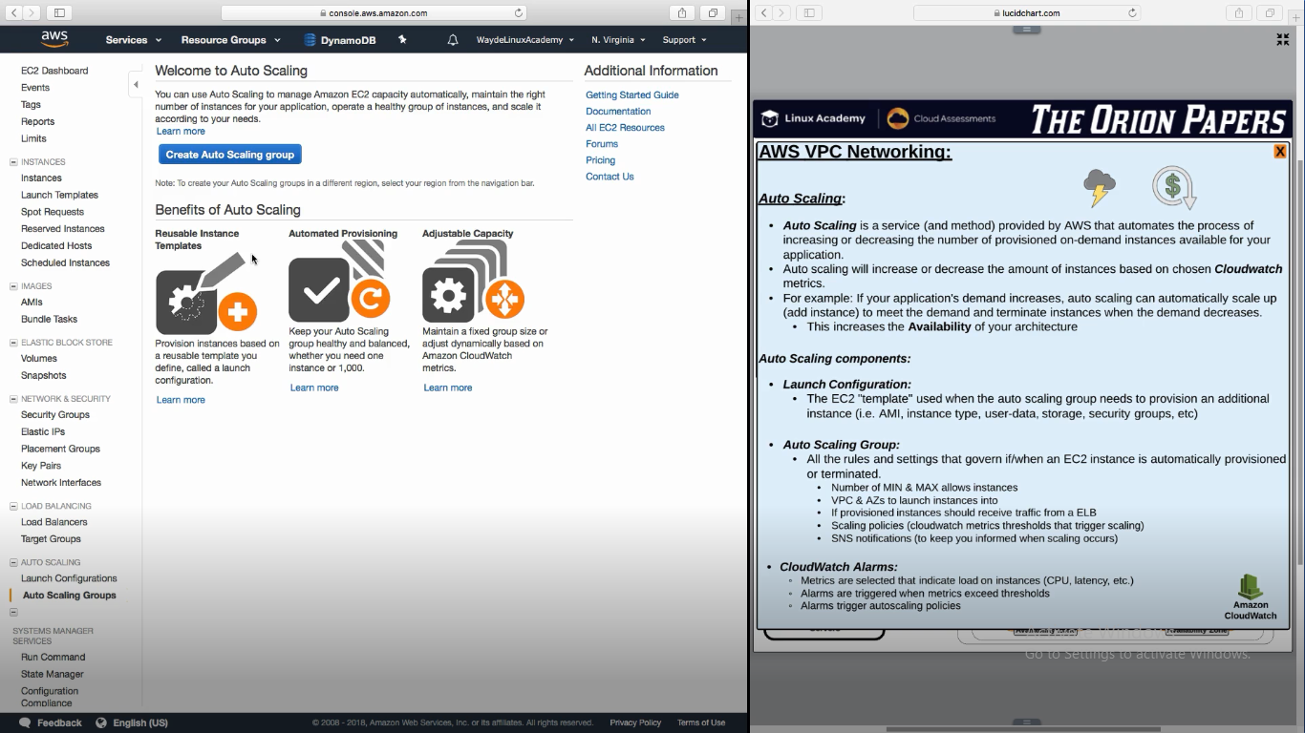

Just click “Create Launch Configuration” in next screen

1. **Create Launch Configuration**

Give a name for the launch configuration

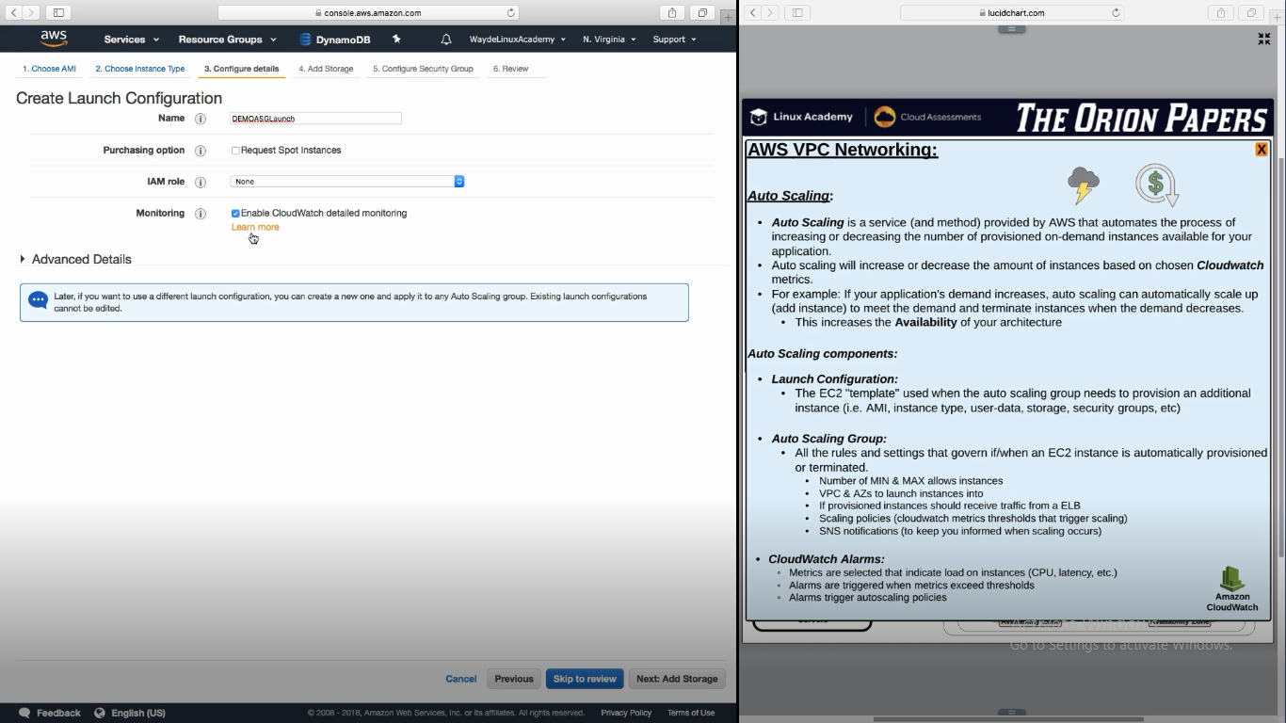

1. Create New security group in following page.

Incoming connection we can give the security group of elastic load balancing SG instead of http

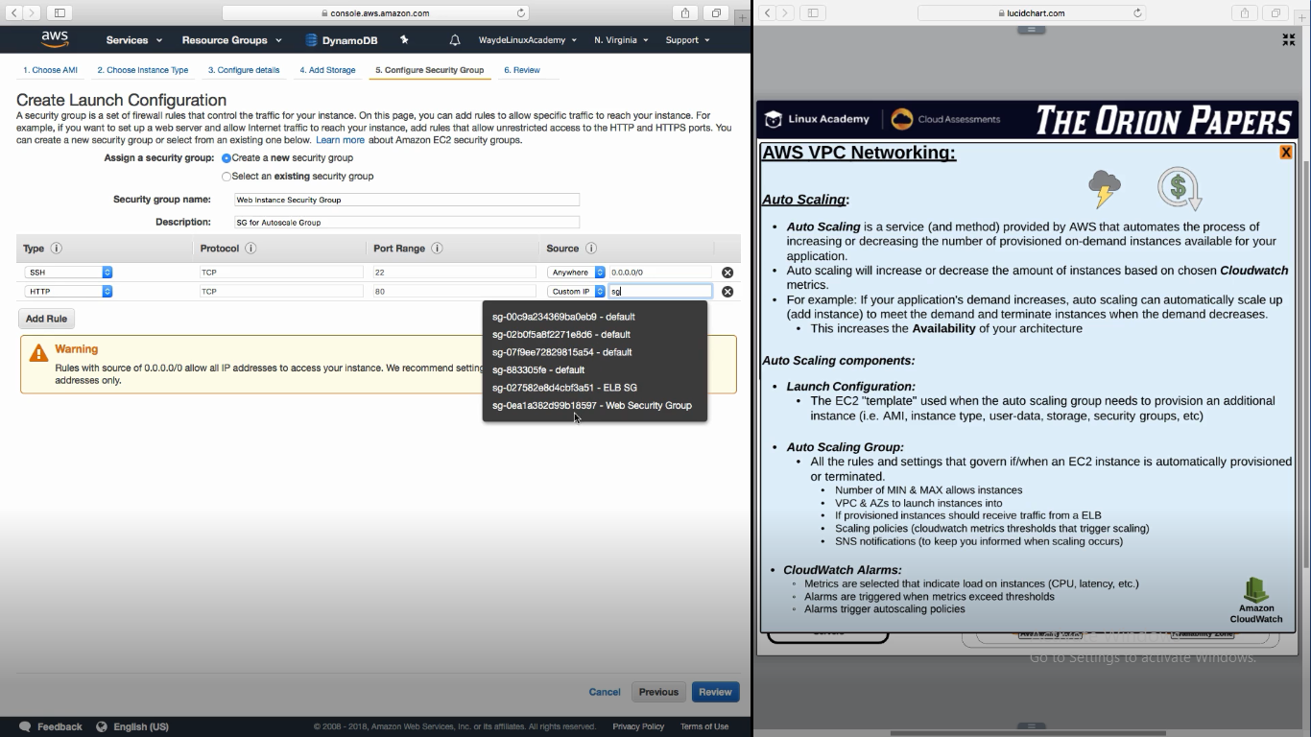

Click on “Launch Configuration”. It will complete the Launch Configuration and go to “Auto Scaling Group” creation

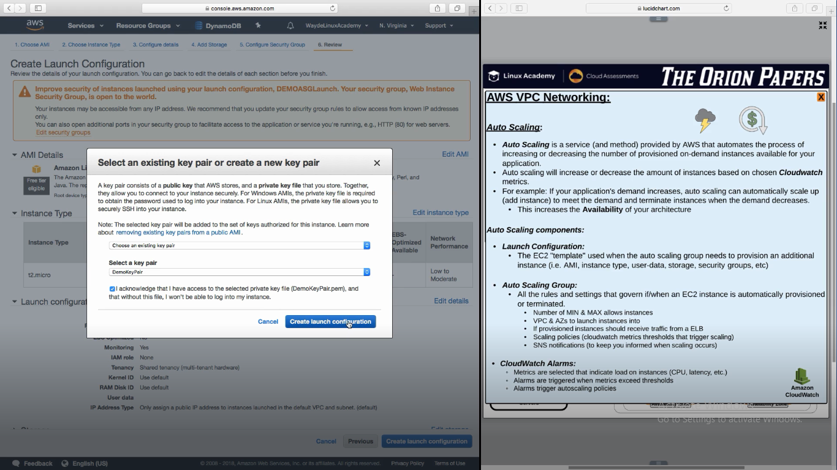

Select how many instance we need while launching

Here we are launching the instance in private instances

Here we are selecting the load balancer which we created in advanced section

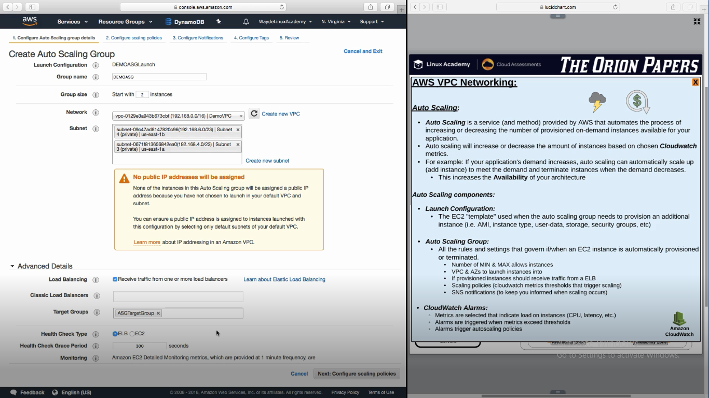

Give auto scaling policies

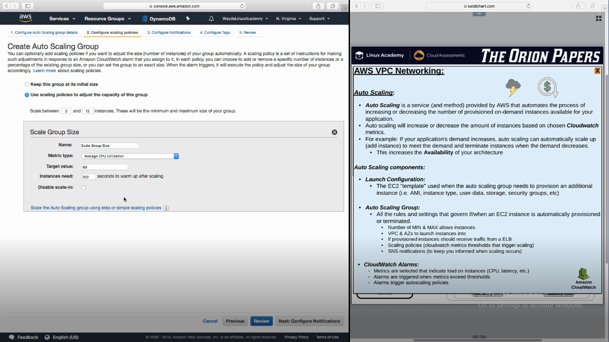

Add Notification – SNS (Simple Notification Service)

Tags

Review

Above 3 are optional

Save

Below two instances are being launched by the auto scaling group we created

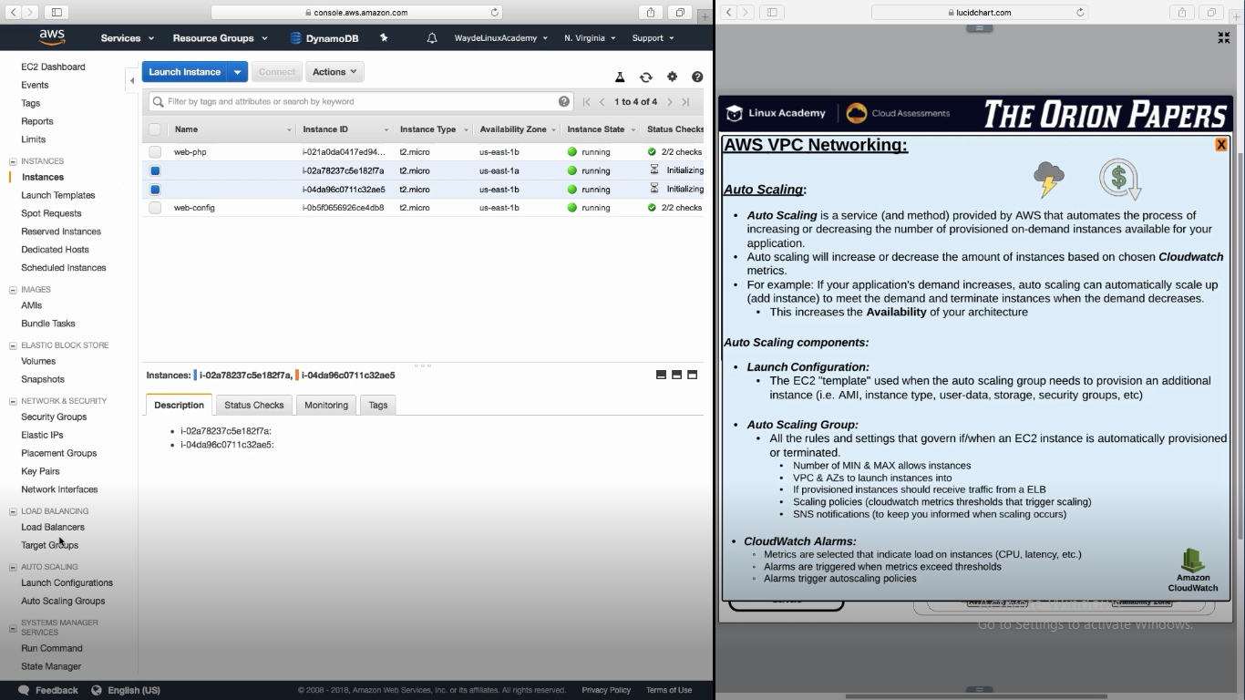

In target group we can see instances are healthy

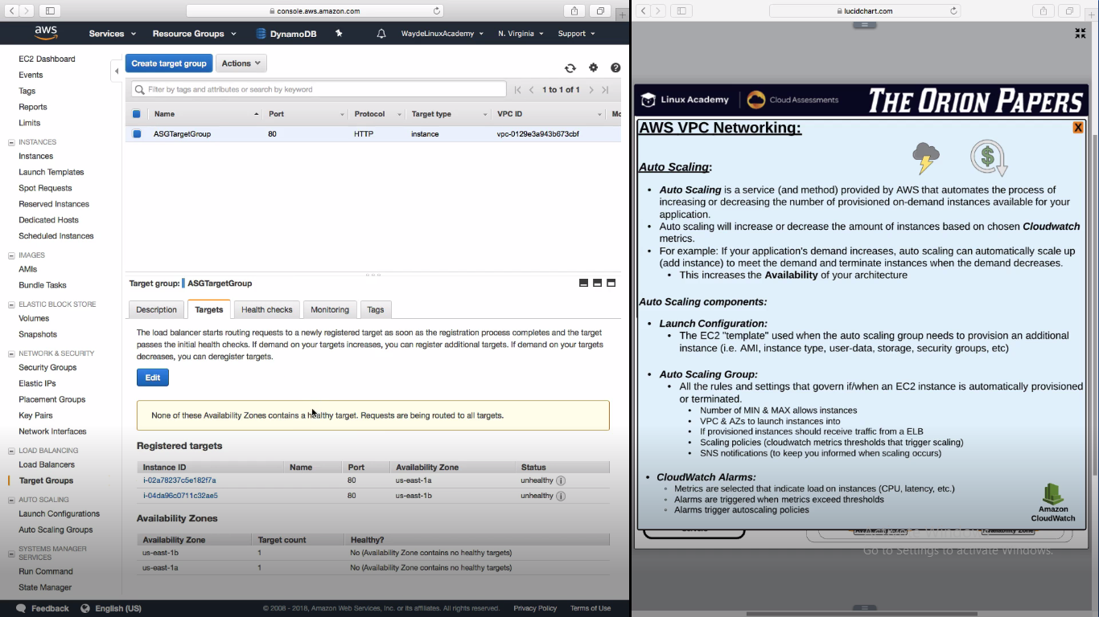

Reference:

Autoscaling is one of the compelling reasons to migrate to the cloud. In this lesson, we will show how to configure your environment to automatically scale.

**AWS now offers Autoscaling Groups with Multiple Instance Types. This will allow you to have full control over the instances that you can use in your group, as well as mix On-Demand and Spot instances.**

**For more information on Autoscaling with Multiple Instances, click the link here :**[**https://aws.amazon.com/blogs/aws/new-ec2-auto-scaling-groups-with-multiple-instance-types-purchase-options/**](https://aws.amazon.com/blogs/aws/new-ec2-auto-scaling-groups-with-multiple-instance-types-purchase-options/)